1-- total number of orders
select distinct(count(distinct id)) as total_orders from Orders
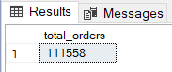

2--List the Order Sources ordered by number of orders.
select o.Source , count(o.id) as number_of_orders from Orders o
group by o.Source
order by number_of_orders
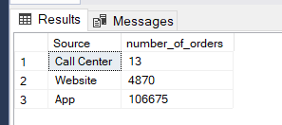
3--Calculate the overall fulfilment rate (Delivered Orders / Total Orders)

SELECT
round(CAST(SUM(CASE WHEN ost.StateName = 'Delivered' THEN 1 ELSE 0 END) AS FLOAT)
/ COUNT(*)*100 ,2) as fulfilment_rate
FROM Orders o inner join [dbo].[OrderStateTypes] ost
on o.OrderStateTypeId =ost.OrderStateTypeId
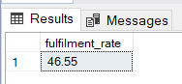
4--Find the average order value month over month
with averageordervalue as(
SELECT
YEAR(o.CreatedON) AS OrderYear,
MONTH(o.CreatedON) AS OrderMonth,
COUNT(DISTINCT o.id) AS TotalOrders,
SUM(oi.price * oi.quantity) AS TotalRevenue,
ROUND(SUM(oi.price * oi.quantity) * 1.0 / COUNT(DISTINCT o.id), 2) AS aov
FROM Orders o
INNER JOIN [dbo].[OrderItems] oi
ON o.Id = oi.orderid
GROUP BY YEAR(o.CreatedON) ,MONTH(o.CreatedON)
)
select OrderYear,OrderMonth,aov ,
lag(aov) over(order by OrderYear , OrderMonth ) as prevAOV,
cast((aov - lag(aov) over(order by orderyear ,ordermonth)) * 100.0/nullif(lag(aov) over(order by orderyear,ordermonth),0) as decimal(10,2)) as MOM_AOV_percentage
from averageordervalue
ORDER BY orderyear , ordermonth
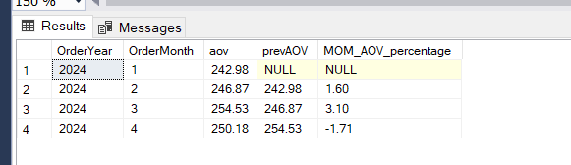

5--Retrieve the number of scheduled orders and their fulfilment rate we have two types of scheduled (scheduled and scheuled vezeeta)
SELECT
count(case when statename = 'Scheduled' then 1 END) AS ScheduledOrders,
COUNT(CASE WHEN statename = 'Delivered' THEN 1 END) AS DeliverdOrders,
COUNT(CASE WHEN statename = 'Scheduled' THEN 1 END) * 1.0
/ NULLIF(COUNT(CASE WHEN statename = 'Delivered' THEN 1 END),0) AS FulfilmentRate
FROM Orders o full join [dbo].[OrderStateTypes] ost
on o.OrderStateTypeId=ost.OrderStateTypeId
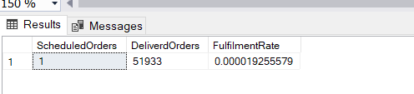

6--Find the top 3 reasons for not fulfilled orders with their percentages from total orders.
--for no fulfilled (Dispensed,Canceled,Rejected By Pharmacy,Rejected By Delivery,Rejected By Vezeeta,Pay. Failed,Cancelled,Items Not Updated)

SELECT TOP 3 ost.StateName AS NotFulfilmentReason,
COUNT(DISTINCT o.Id) AS NumberOfOrders,
ROUND(COUNT(DISTINCT o.Id) * 100.0 / (SELECT COUNT(*) FROM Orders), 2) AS PercentageOfTotal
FROM Orders o
INNER JOIN OrderStateTypes ost ON o.OrderStateTypeId = ost.OrderStateTypeId
WHERE ost.StateName IN (
'Dispensed',
'Canceled',
'Rejected By Pharmacy',
'Rejected By Delivery',
'Rejected By Vezeeta',
'Pay. Failed',
'Items Not Updated',
'Cancelled'
)
GROUP BY ost.StateName
ORDER BY NumberOfOrders DESC;

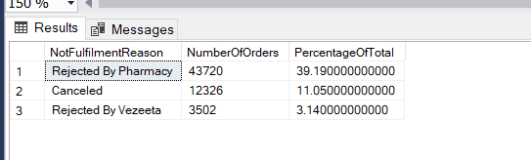

-----------------------------------
--Product Analysis
-----------------------------------

1--Product analysis based on data doesn't have a product name we can got a product key in orderitems

--first we need to make non clustered index on product key to make it run fast
CREATE NONCLUSTERED INDEX IX_IndexName
ON [dbo].[OrderItems] (ProductKey);

--apply the sql statement
--Identify the top 5 Products with the highest number of orders.
select top 5 oi.ProductKey , count(distinct o.id) as total_of_orders from orders o inner join [dbo].[OrderItems] oi
on o.id =oi.OrderId
group by oi.productkey
order by total_of_orders desc
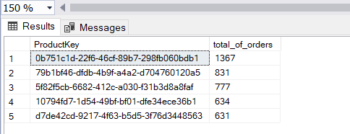

2--Identify the top 5 Products with the highest amount of Sales Value.

select top 5 oi.ProductKey ,sum(oi.Quantity*oi.Price) as amount from orderitems oi
group by oi.ProductKey
order by amount desc
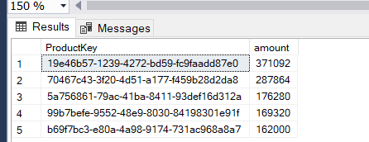

---------------------------------------------------------------------------
--Pharmacies Analysis
---------------------------------------------------------------------------

0-create nonclustered index pharme_idx
on [dbo].[Pharmacies] ([o_Key])

1--Identify the top 5 Pharmacies based on the number of orders.
select top 5 p.o_Key , count(distinct o.id) as number_of_orders from Pharmacies p inner join Orders o
on o.PharmacyKey =p.o_Key
group by p.o_Key
order by number_of_orders desc
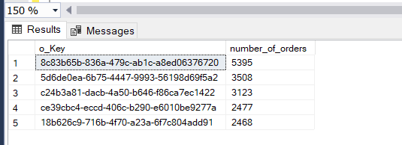

2--Identify the top 5 Pharmacies based on fulfilment rate
select top 5 p.o_Key ,
round(cast(sum(case when os.StateName='Delivered' then 1 else 0 end) as float)/count(distinct o.id), 2)as fulfilment_rate
from Pharmacies p inner join orders o
on p.o_Key=o.PharmacyKey inner join OrderStateTypes os
on o.OrderStateTypeId =os.OrderStateTypeId
group by p.o_Key
order by fulfilment_rate desc

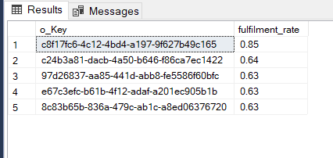

3--List all the pharmacies with their customer time (Time between order creation and the last order state) in ascending order
3-- i used to calculate it based on pharmacy key and user key and but two conditions
3--as success in test flag and also as delivered to make it simple and check manualy
3--if the calculation of time true and get the target or not

select p.o_Key,o.UserKey,o.Id,
CONVERT(VARCHAR, DATEADD(SECOND, DATEDIFF(SECOND, max(o.CreatedOn), max(os.TimeStamp)), 0), 108) AS TimeDiffsecond
from Pharmacies p inner join Orders o
on p.o_Key=o.PharmacyKey inner join OrderStates os
on o.id=os.OrderId
where p.[Test Flag]=1 and os.OrderStateTypeId=4
group by p.o_Key,o.UserKey,o.id
order by TimeDiffsecond

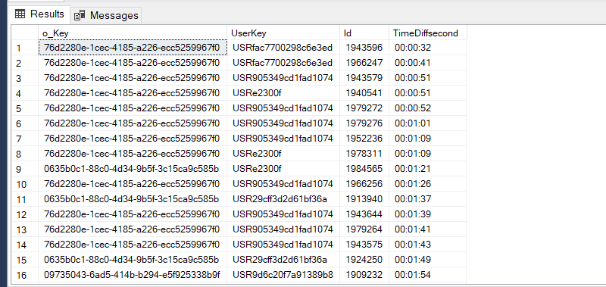

4--List all the pharmacies with their customer time (Time between order creation and the last order state) in ascending order
4--the full calculation that's on all situation
select p.o_Key,o.UserKey,o.Id,
CONVERT(VARCHAR, DATEADD(SECOND, DATEDIFF(SECOND, max(o.CreatedOn), max(os.TimeStamp)), 0), 108) AS TimeDiffsecond
from Pharmacies p inner join Orders o
on p.o_Key=o.PharmacyKey inner join OrderStates os
on o.id=os.OrderId
group by p.o_Key,o.UserKey,o.id
order by TimeDiffsecond
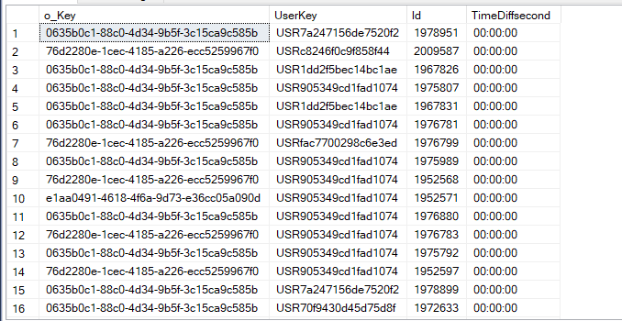

5--List all the pharmacies with their delivery time (Time between accepting the order and order delivery) in ascending order
SELECT
p.o_Key,
o.id AS Orderid,
convert(varchar,dateadd(MINUTE ,DATEDIFF(minute,
MAX(CASE WHEN os.OrderStateTypeId = 7 THEN os.timestamp END),
MAX(CASE WHEN os.OrderStateTypeId = 4 THEN os.timestamp END)
),0),108) AS DateDiffInMinutes
FROM Pharmacies p
INNER JOIN Orders o
ON p.o_Key = o.PharmacyKey
INNER JOIN OrderStates os
ON o.id = os.OrderId
GROUP BY p.o_Key, o.id
ORDER BY DateDiffInMinutes asc;
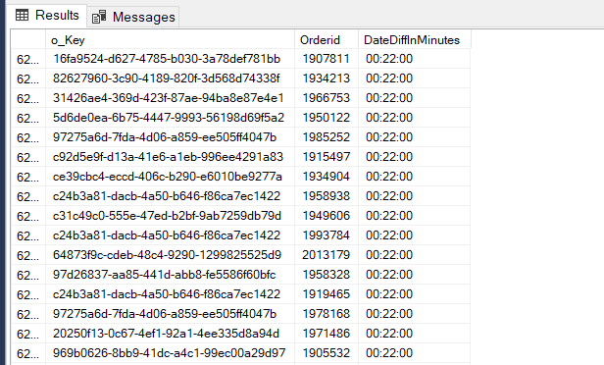

6--List the top 5 order states before rejecting the orders (Only for rejected orders) with their total number of orders.
6--ranked orders that will be based on max time stamp
WITH RankedStates AS (
SELECT
o.id AS OrderID,
ost.StateName,
os.Timestamp,
ROW_NUMBER() OVER (PARTITION BY o.id ORDER BY os.Timestamp DESC) AS row_num
FROM Orders o
INNER JOIN OrderStates os
ON o.id = os.OrderId
INNER JOIN OrderStateTypes ost
ON os.OrderStateTypeId = ost.OrderStateTypeId
WHERE ost.StateName IN ('Rejected By Pharmacy','Rejected By Delivery','Rejected By Vezeeta')
),
StateBeforeReject AS (
SELECT
o.id AS OrderID,
LAG(ost.StateName) OVER (PARTITION BY o.id ORDER BY os.Timestamp) AS StateBeforeReject
FROM Orders o
INNER JOIN OrderStates os
ON o.id = os.OrderId
INNER JOIN OrderStateTypes ost
ON os.OrderStateTypeId = ost.OrderStateTypeId
)
SELECT TOP 5
s.StateBeforeReject,
COUNT(DISTINCT s.OrderID) AS NumberOfOrders
FROM StateBeforeReject s
WHERE s.StateBeforeReject NOT IN ('Rejected By Pharmacy','Rejected By Delivery','Rejected By Vezeeta')
GROUP BY s.StateBeforeReject
ORDER BY NumberOfOrders DESC;

